SYSTEMS DESIGN SPECIFICATION

SALARY AND PERFORMANCE MANAGEMENT SYSTEM

1. **Introduction/Management Summary**  
   1.1 Purpose of the Document..................................................3  
   1.2 Brief Overview of the Project.............................................3  
   1.3 High-Level Scope............................................................3  
   1.4 Assumptions.................................................................3
2. **System Components**  
   2.1 Application Detailed Design............................................4

2.1.1 User Interface.........................................................4  
2.1.2 Modules.................................................................5

2.1.2.1 User Authentication Module............................6  
2.1.2.2 Salary Calculation Module...............................6  
2.1.2.3 Performance Evaluation Module........................7  
2.1.2.4 Database Management Module........................7  
2.1.2.5 Reporting and Analytics Module........................7

2.1.3 Software Package Interface...................................7

1. **System Environment**  
   3.1 Constraints.................................................................8

3.1.1 Operational Constraints..........................................8  
3.1.2 Security Constraints...............................................8

3.2 Hardware.................................................................8

3.2.1 Server Requirements.............................................8  
3.2.2 Client Requirements...............................................8

3.3 Network Specifications.................................................9

3.3.1 LAN Topology......................................................9  
3.3.2 Communication Detailed Design...........................9

1. **Conclusion**

4.1 Summary.................................................................9

### Introduction/Management Summary:

**Purpose of the Document:**

This document outlines the design specifications for the development of a new Salary and Performance Management System. It aims to provide a comprehensive guide for the development team, highlighting the system's purpose, scope, and key components.

**Brief Overview of the Project:**

The project involves designing and implementing a robust system for managing employee salaries and performance reviews. The system will automate performance reviews, salary management, and provide relevant insights for effective human resource management.

**High-Level Scope:**

* **In Scope:**
  + Employee performance reviews projections and actuals (managed by managers and viewed by employees)
  + Employee salary projections and actuals (managed by managers and viewed by employees)
  + QPR
  + Data storage and retrieval
  + User authentication and authorization
  + Reporting and notifications
  + Employee data that is required for salary and performance management.
* **Out of Scope:**
  + HR & Payroll
  + Tax
  + Legal compliance (external legal department responsibility)
  + Employee personal data beyond what's required for salary and performance management.

**Assumptions:**

* All required resources are available.
* The system will be developed using industry-standard security practices.
* Hardware and network infrastructure will meet specified requirements.
* Users have the necessary permission to access and modify relevant data.
* Employees have the required skills.
* There is enough budget.

### System Components:

User Interface Overview:

* Log in page that requires only employee ID and password.
* Simple yet intuitive dashboard for managers as well as a different “view only” version for staff, based on their credentials.
* PR projections and actuals page for the manager to enter PR data and submit for approval.
* PR projections and actuals page for staff to View.
* Salary projections and actuals page for the manager to enter Salary data and submit for approval.
* Salary projections and actuals page for staff to view Salary data.
* QPR page
* Notifications and reports

Sample of our design:

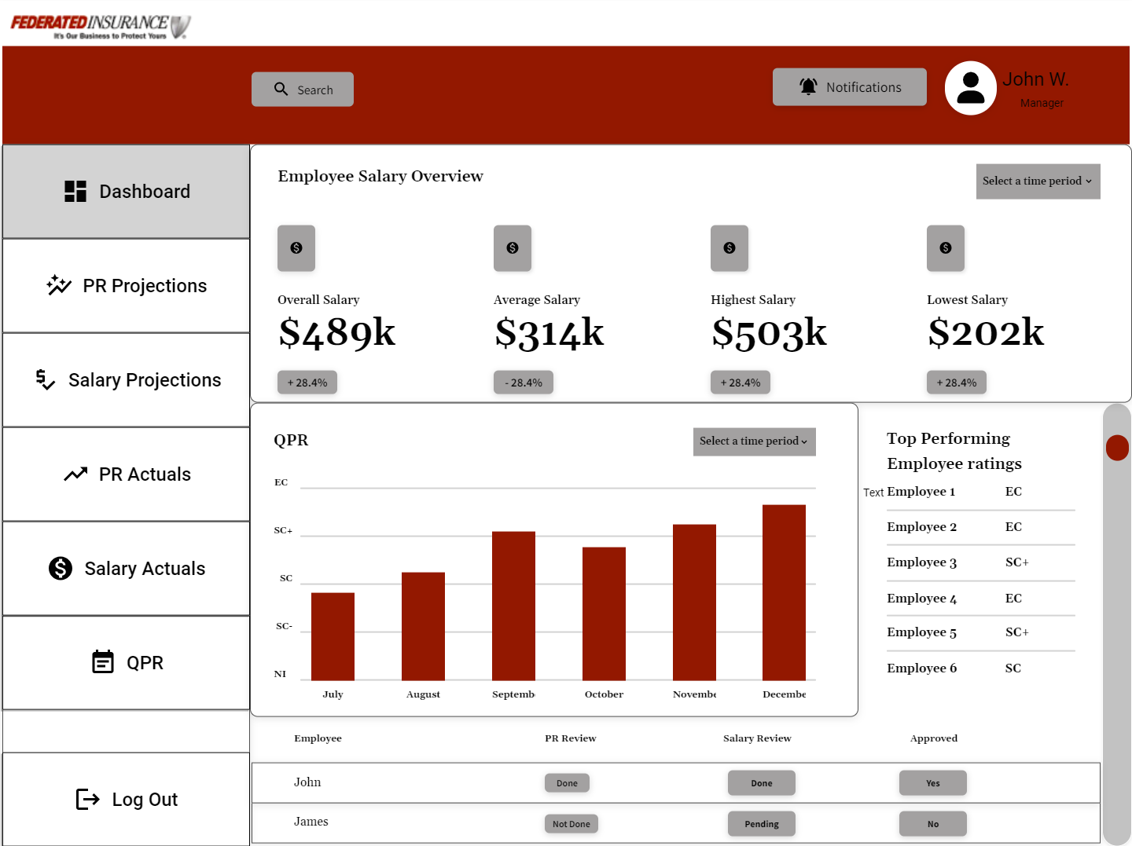

**Application Detailed Design**:

1. **User Authentication Module:**
   * Responsible for authenticating users and managing access rights.
   * Utilizes industry-standard encryption protocols.

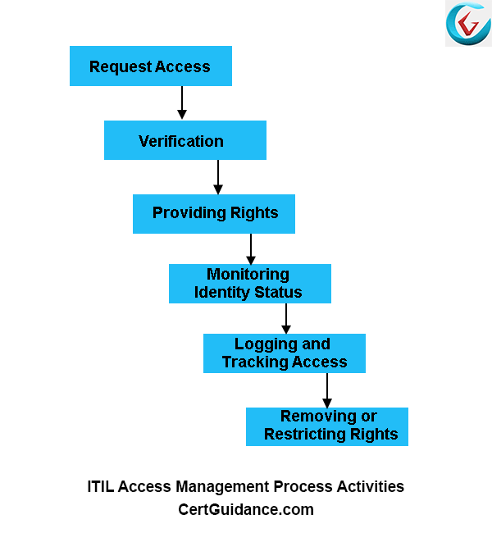

1. **Salary Management Module:**
   * Calculates employee salaries based on predefined rules.
   * Integrates with external payroll systems for tax calculations.
2. **Performance Review Module:**
   * Tracks employee performance metrics.
   * Generates reports for managerial review.

1. **Database Management Module:**
   * Manages data storage, retrieval, and integrity.
   * Utilizes a relational database system.

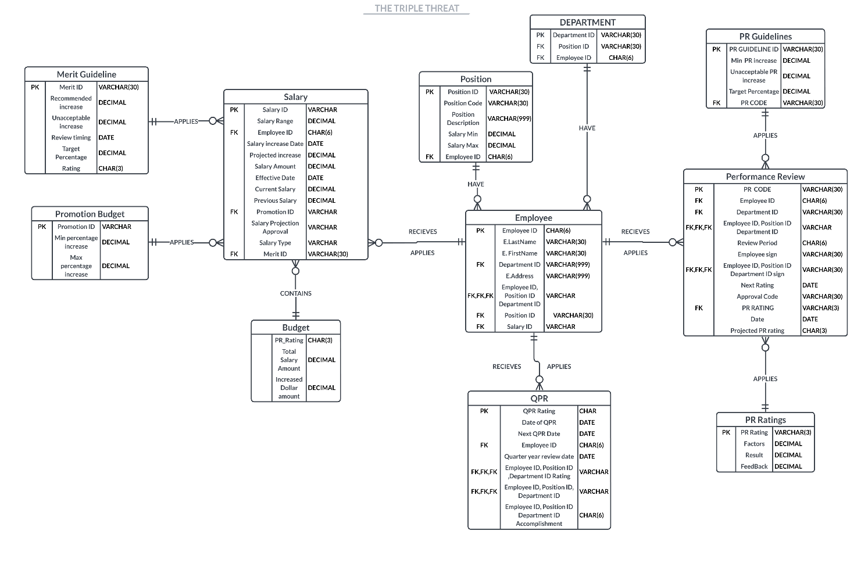

1. **Reporting and Notification Module:**
   * Generates notifications and reports on salary and performance for each employee to view.
   * Provides analytics for HR decision-making.

**Inputs:** Input data is gained from HR which includes employee data like employee name, department, position, supervisor, performance, and previous/current salary. Most, if not all, of the input is done by the manager.

**Outputs:** New and updated salary to HR, notifications and reports of PR reviews and salary for employees to view and for future reviews.

**Database:** MySQL database will be used which will store data for the system like user logins and reviews from the last 5 years.

**Software Package Interface:** No software is purchased; all is developed in-house.

**Integration:** The new system should integrate with the existing HR system to input and output data.

### System Environment:

Constraints:

* Online response time: < 2 seconds for critical operations.
* Data storage: Minimum 1-year retention for performance records.
* Security: Complies with industry and legal standards.

**Hardware:**

Server Requirements:

* Dual-core processors (minimum)
* 16 GB RAM (minimum)
* Storage: SSD for database, HDD for general storage
* Redundant power supplies
* Rack-mounted servers for scalability

Client Requirements:

* Standard desktop/laptop configurations
* Minimum screen resolution: 1280x800
* High-speed internet connectivity

Network Specifications:

* LAN Topology: Star topology for internal communication
* Data Formats: JSON for communication between modules
* Backup and Recovery: Regular automated backups with offsite storage

**Communication Detailed Design:**

Update Frequency:

* Database Files: Daily updates for new employee data
* Performance Records: Quarterly updates
* Transaction Frequency: Real-time for salary adjustments and performance updates

LAN Topology:

* Servers: Centralized in the data center

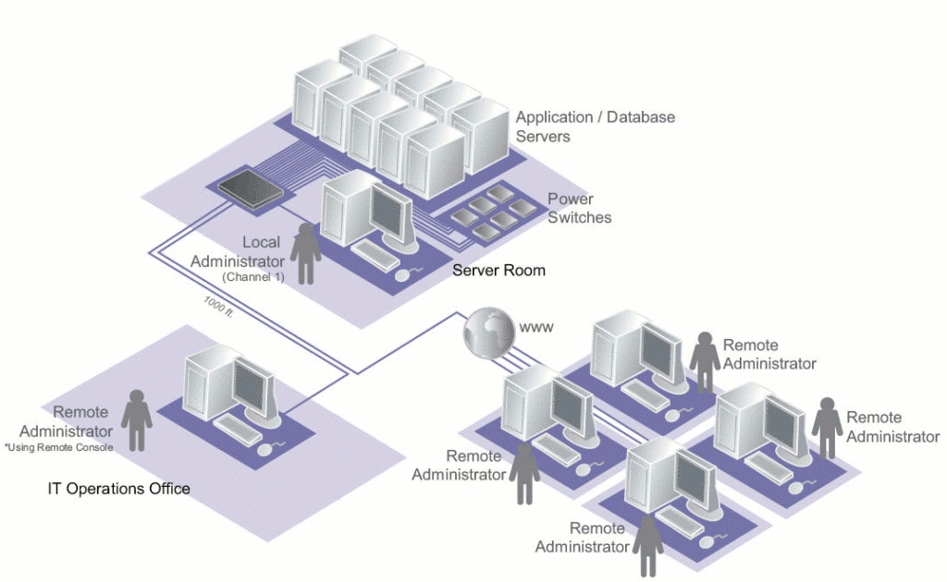

* Clients: Distributed across departments

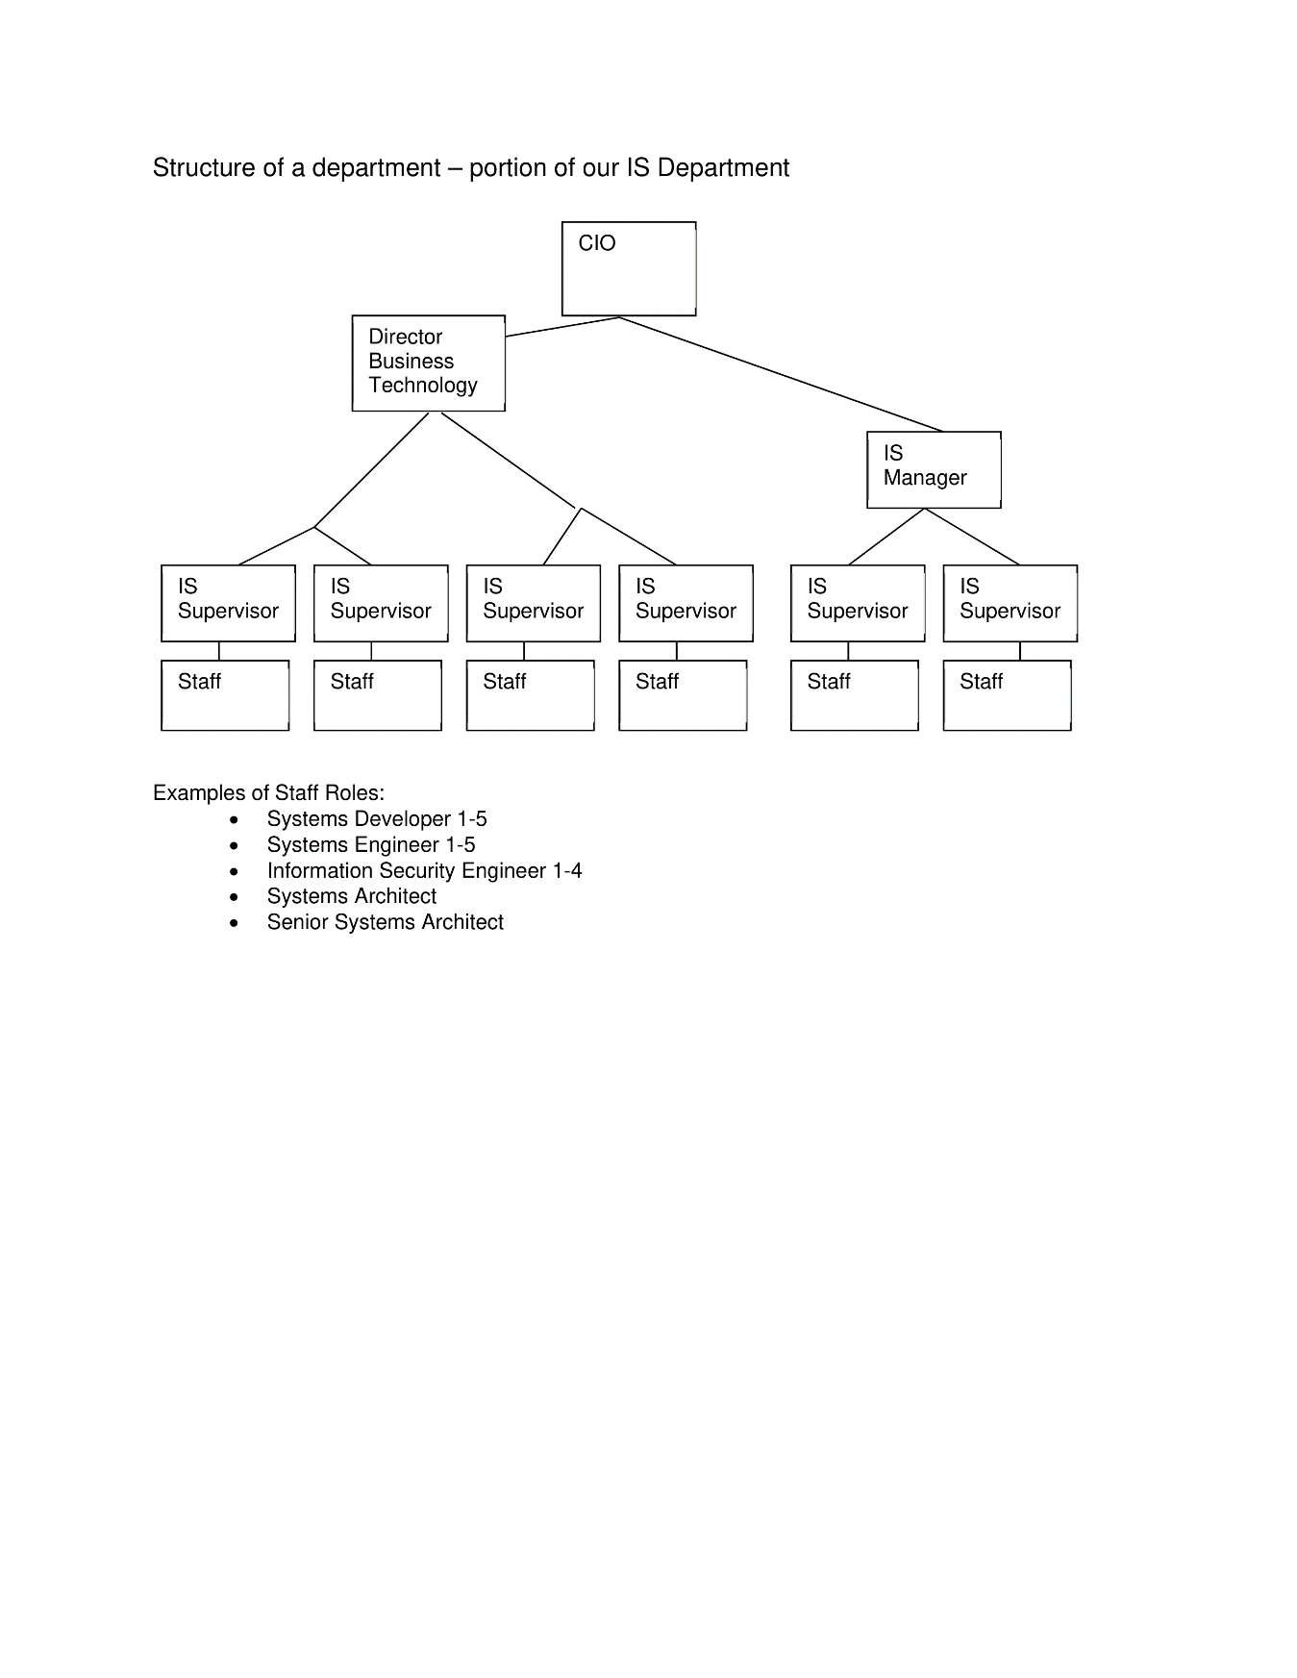

* Communication Protocols: HTTPS for secure data transmission

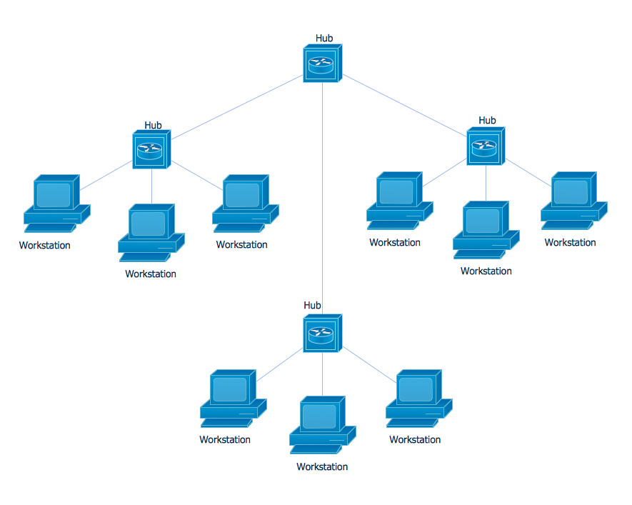

Support Processing:

* Backup and Recovery: Nightly backups with versioning
* Start-up Processing: Automated system checks and updates.
* File Retention: Archival of old data for compliance

### Conclusion:

This System Design Specification provides a detailed blueprint for the development of the Salary and Performance Management System. The outlined components, interfaces, and environmental requirements aim to guide the development team in creating a robust and efficient system that meets the organization's needs.